**EXECUTION STEPS**

**HOW TO RUN?**

**Step 1:**

* Open the Contik OS with Vmware workstation.And login into contiki user password: user

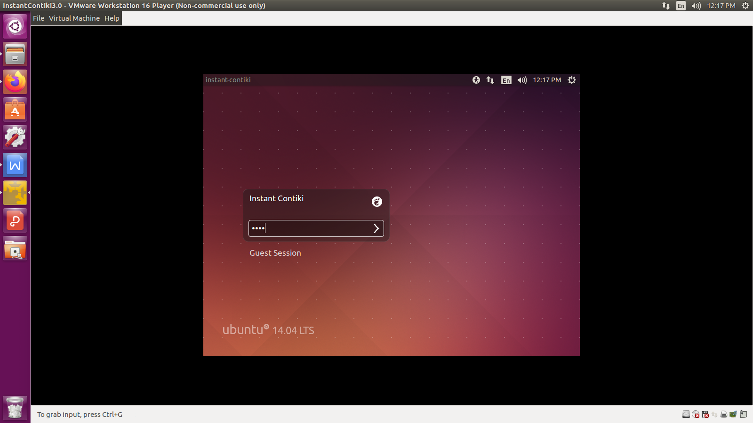

**HOW TO PATCH FILES?**

First copy the project folder(Which we have provided to you).Then paste that to the contiki desktop.

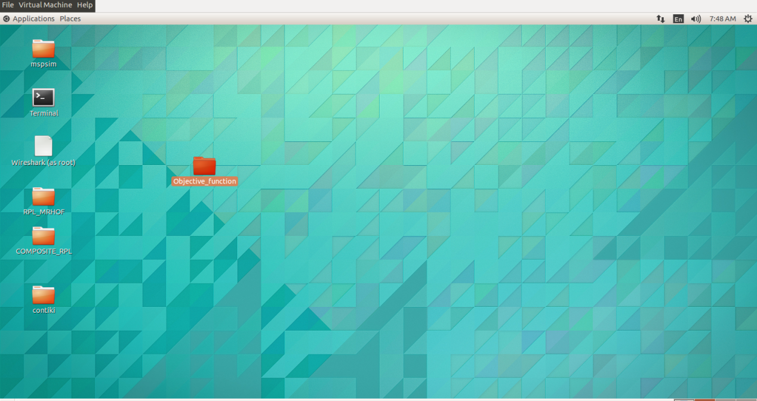

1. Then go to the Places in upper corner

Places - > Home folder

Here you have one folder named contiki. This is the default folder.

2. Then create 2 separate folders named as COMPOSITE_RPL and RPL-MRHOF.

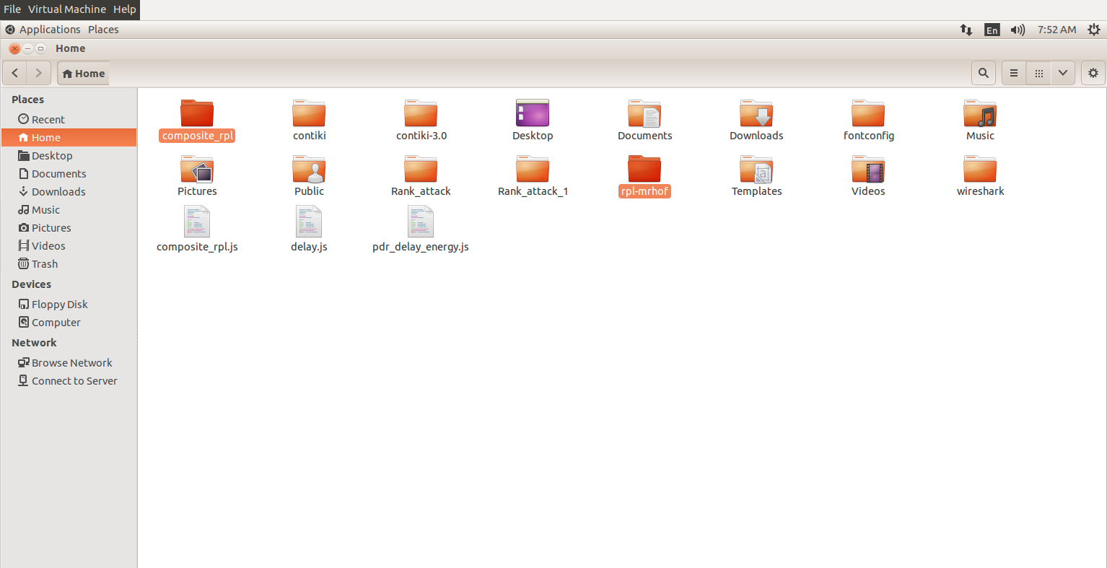

3. Then copy the contiki folder, and paste that into both COMPOSITE_RPL and RPL-MRHOF.

**Exisiting**

**Rpl_MRhof file patching**

1. Then go to the Objective_Function -> RPL_MRHOF**,**

Copy **net** folder

And paste that to the below path,  **/home/user/RPL_MRHOF/contiki/core**

Here it already have **net** folder, delete that one. And paste the above **copied net** folder here.

2. Similarly go to the Objective_Function- > Rpl_MRhof**,**

Copy rpl-udp folder

And paste that to the below path,  **/home/user/RPL_MRHOF/contiki/examples/ipv6**

Here it already have **rpl-udp** folder, delete that one. And paste the above **copied rpl-udp** folder here.

**Proposed**

**Composite_Rpl file patching (Similar steps)**

1. Then go to the Objective_Function- > **COMPOSITE_RPL,**

Copy **net** folder

And paste that to the below path,  **/home/user/COMPOSITE_RPL/contiki/core**

Here it already have **net** folder, delete that one. And paste the above **copied net** folder here.

2. Similarly go to the Objective_Function- > COMPOSITE_RPL**,**

Copy rpl-udp folder

And paste that to the below path,  **/home/user/COMPOSITE_RPL/contiki/examples/ipv6**

Here it already have **rpl-udp** folder, delete that one. And paste the above **copied rpl-udp** folder here.

**How to execute?**

**Execution:**

1. Open Terminal and 2 tabs; first one is for code compilation, another one is for simulation execution.

Change directory

First tab - > cd **/home/user/RPL_MRHOF/contiki/examples/ipv6/rpl-udp**

And press Enter in your keyboard.

Second tab - > cd **/home/user/RPL_MRHOF/contiki/tools/cooja**

And press Enter in your keyboard.

2. First tab - > type these commands

-> **make clean**

(After prompting)

-> **make TARGET=sky**

3. After compilation, go to second tab and provide this command

-> **ant run**

Note: Sometimes, while proving ant run command, mspsim error is arise.

For that download mspsim folder from the link <https://github.com/contiki-os/mspsim>

Then download the zip folder -> (after downloading) Unzip mspsim-master folder -> and renamed that as mspsim -> After that copy the mspsim folder and paste that in the **/home/user/RPL_MRHOF/contiki/tools** location. It already has the mspsim folder, delete that folder and paste the copied one here.

Then go to the terminal -> cd **/home/user/RPL_MRHOF/contiki/tools**

**- > make**

Again run the simulation,

4. Then this window is opened.

File -> Open simulation -> Browse -> opn the simulation (.csc file) random25.csc- > open

Then click start button in simulation control

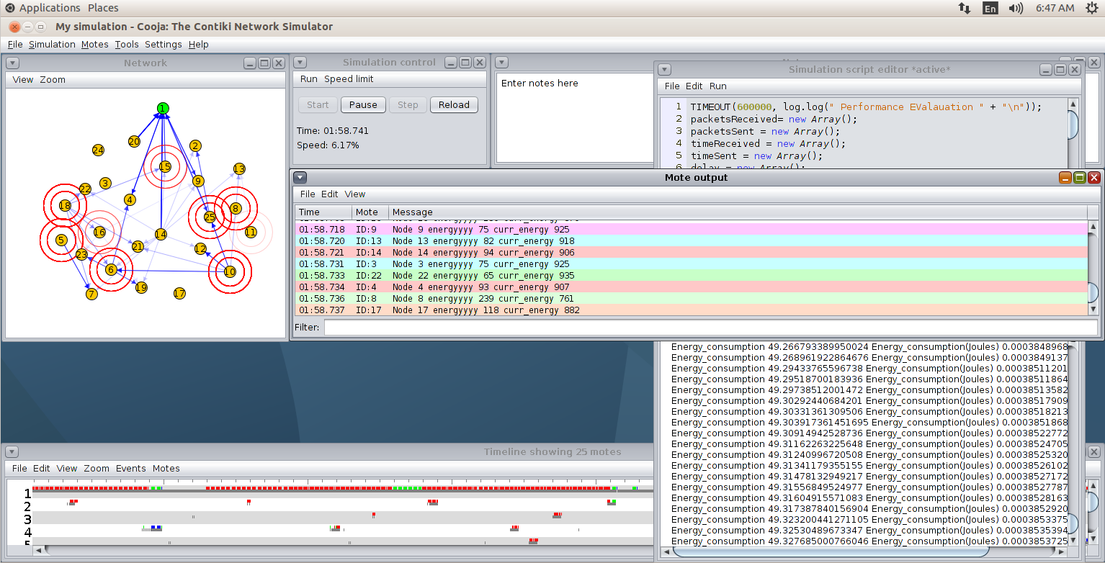

How to save Output?

After the simulation stopped, press ctrl + A and ctrl + C on the Simulation script editor plugin

And paste the result in text editor and save the result.

The similar things need to be followed for simulation control window result.

For Mote output - >Edit -> Copy all data

And paste that to the text editor.

**The similar steps need to followed for random50 node simulation process**

**The similar steps need to followed for proposed process**